Improve your word power
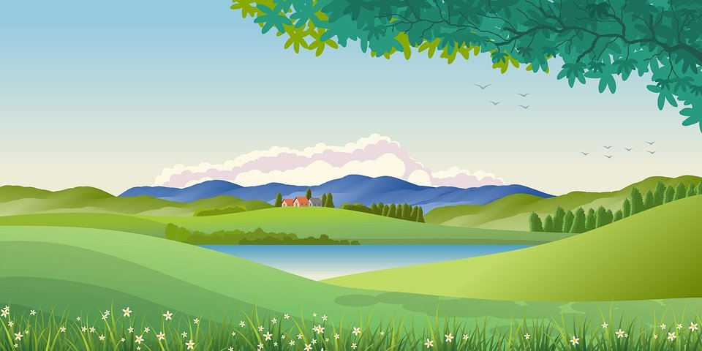
(Bild Pixabay: https://pixabay.com/de/illustrations/illustration-hintergrund-landschaft-4763593/, Zugriff am 02.06.2022)
Vorlage: Arbeitsblatt zur Sammlung von Redemitteln
Find words and phrases for the categories our environment, problems and solutions that match the topics. You can use a dictionary.
Our Environment
- forest
- rainforest
Problems
Solutions

