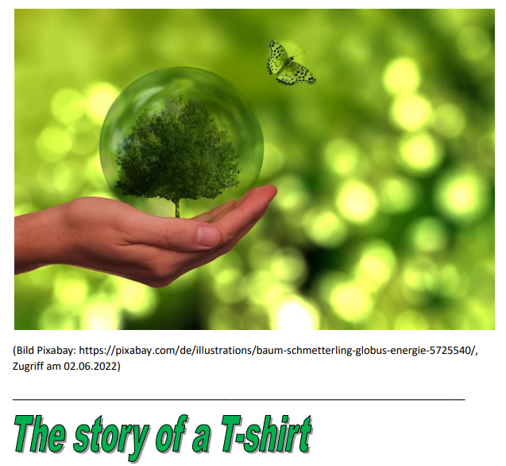
Have you ever asked yourself what it takes to make your T-shirt? What would it tell you about its origin, the way it was produced and found its way into your wardrobe – if it could speak.
Well, its story would sound like this.
May I introduce myself, I am one of the 2 billion T-shirts that are sold and bought all around the world every year. Nearly everyone in Germany owns at least 5 of us.
Typically we begin our lives in a cotton field in China or India. We are mostly made of. Cotton. Cotton seeds are sown, watered and grown. Cotton plants need a lot of water. Water is very important for us – 2700 litres of water is needed to produce one of us. By the way, 2,700 litres of water is enough to fill 30 bathtubs.
Cotton plants have a lot of enemies pests that threaten us. That is why the farmers have to use pesticides. The chemicals used to kill these pests are very dangerous as they harm the health of the farmers and damage ecosystems.
Then the cotton leaves the farms and is sent to the factories where the fabric for the T-shirts is produced. The fabric is treated with heat and chemicals until it is white and soft. Poisonous chemicals are used to dye and smooth the material for T-shirts. The bleach, for example, contains cancer-causing substances like cadmium, lead, chromium, and mercury. A lot of water is needed again and this toxic waste water often goes directly into rivers and oceans.
The finished cloth is now sent to Bangladesh, China, India or Turkey where the T-shirts are sewn in sweatshops. Here many people work hard under poor conditions with low wages.
Finally we are sent to shops in a countries where people can afford to buy us. After someone buys us, we often become their favourite T-shirt – but only for a short time. When people are sick of us we are simply thrown away and often end up in landfills. What a sad ending.
Here are some more facts you should know about the production of fast fashion:
- Textile production is responsible for 10% of the global carbon emissions.
- Around 11% of the world’s pesticides are used on cotton fields.
- 100 million tonnes of textiles end up in landfills every year.
- The energy to produce clothes in China is produced by coal, which is definitely very bad for our environment.
Any ore questions?
Now you might wonder what you can do:
Consider shopping second-hand. Don’t throw away your clothes. Donate them or use them as cleaning rags. Have a clothes swap party. Ask yourself what you really need to be happy.
__________________________________________________________________
Assignment:
Read the text and find out.
Fill in the gaps.
1. About ___________ T-shirts are sold every year.
2. Farmers in cotton fields use their ____________ to protect __________ but they also harm the ________________.
3. It takes ______________ of water to produce one T-shirt.
4. The toxic water __________________ rivers and oceans.
5. Cadmium, lead, chrome and mercury are ______________ chemicals.
6. The Workers who sew the T-shirts do not earn _____________________.
7. ____________________ of textiles are thrown away as waste every year.

If you are interested in some more facts, search the Internet.

Schädlingsbekämpfungsmittel
Bleichmittel
giftige Schwermetalle

