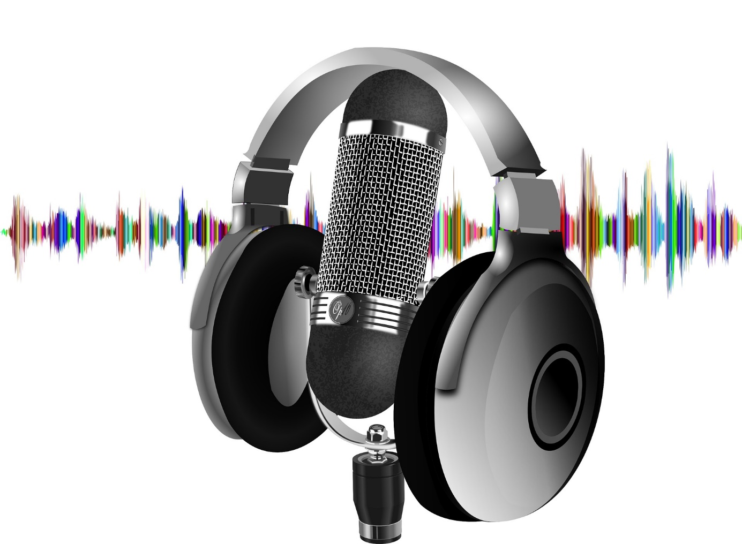
https://pixabay.com/de/photos/podcast-headset-mikrofon-welle-4205874/

