

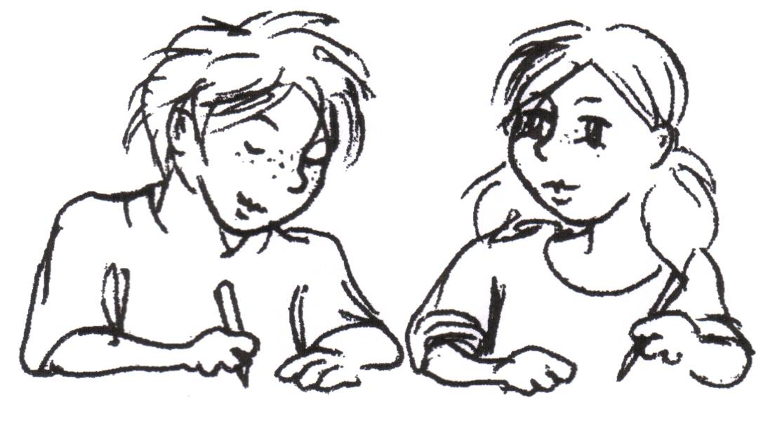

**Name: _______________ Vorname:**

**Klasse: _______________ Datum: _______________**

|  |  |  |  |  |  |  |  |  |  |  |  |  |
| --- | --- | --- | --- | --- | --- | --- | --- | --- | --- | --- | --- | --- |
|  |  |  |  |  |  |  |  |  |  |  |  |  |
|  |  |  |  |  |  |  |  |  |  |  |  |  |
|  |  |  |  |  |  |  |  |  |  |  |  |  |
|  |  |  |  |  |  |  |  |  |  |  |  |  |
|  |  |  |  |  |  |  |  |  |  |  |  |  |
|  |  |  |  |  |  |  |  |  |  |  |  |  |
|  |  |  |  |  |  |  |  |  |  |  |  |  |
|  |  |  |  |  |  |  |  |  |  |  |  |  |

1. Löse die Aufgaben.

|  |  |  |  |  |  |  |
| --- | --- | --- | --- | --- | --- | --- |
| a) | 2 424 | + | 76 | = |  | |
| b) | 40 | **·** | (85 - 73) | = |  |
| c) | 987 | - | 87 | = | 588 + |
| d) | 7 200 | **:** | 80 | = |  |

1. Wie viele Sekunden hat eine Stunde?

|  |  |  |  |  |  |  |  |  |  |  |  |  |  |  |  |  |  |  |  |  |  |  |  |  |  |  |  |  |
| --- | --- | --- | --- | --- | --- | --- | --- | --- | --- | --- | --- | --- | --- | --- | --- | --- | --- | --- | --- | --- | --- | --- | --- | --- | --- | --- | --- | --- |
|  |  |  |  |  |  |  |  |  |  |  |  |  |  |  |  |  |  |  |  |  |  |  |  |  |  |  |  |  |
|  |  |  |  |  |  |  |  |  |  |  |  |  |  |  |  |  |  |  |  |  |  |  |  |  |  |  |  |  |
|  |  |  |  |  |  |  |  |  |  |  |  |  |  |  |  |  |  |  |  |  |  |  |  |  |  |  |  |  |
|  |  |  |  |  |  |  |  |  |  |  |  |  |  |  |  |  |  |  |  |  |  |  |  |  |  |  |  |  |
|  |  |  |  |  |  |  |  |  |  |  |  |  |  |  |  |  |  |  |  |  |  |  |  |  |  |  |  |  |

Antwort: ____________________________________________________________

1. Welche Zahl erhältst du, wenn du die Differenz der Zahlen 100 und 23

durch 7 dividierst?

|  |  |  |  |  |  |  |  |  |  |  |  |  |  |  |  |  |  |  |  |  |  |  |  |  |  |  |  |  |
| --- | --- | --- | --- | --- | --- | --- | --- | --- | --- | --- | --- | --- | --- | --- | --- | --- | --- | --- | --- | --- | --- | --- | --- | --- | --- | --- | --- | --- |
|  |  |  |  |  |  |  |  |  |  |  |  |  |  |  |  |  |  |  |  |  |  |  |  |  |  |  |  |  |
|  |  |  |  |  |  |  |  |  |  |  |  |  |  |  |  |  |  |  |  |  |  |  |  |  |  |  |  |  |
|  |  |  |  |  |  |  |  |  |  |  |  |  |  |  |  |  |  |  |  |  |  |  |  |  |  |  |  |  |
|  |  |  |  |  |  |  |  |  |  |  |  |  |  |  |  |  |  |  |  |  |  |  |  |  |  |  |  |  |
|  |  |  |  |  |  |  |  |  |  |  |  |  |  |  |  |  |  |  |  |  |  |  |  |  |  |  |  |  |

Antwort: ___________________________________________________________­_

1. Welche Ziffern fehlen hier?

|  |  |  |  |  |  |  |  |  |  |  |  |  |  |  |  |
| --- | --- | --- | --- | --- | --- | --- | --- | --- | --- | --- | --- | --- | --- | --- | --- |
|  |  |  |  |  |  |  |  |  |  |  |  |  |  |  |  |
|  |  |  |  |  |  |  |  |  |  |  |  |  |  |  |  |
|  |  |  |  |  |  |  |  |  |  |  |  |  |  |  |  |
|  |  |  |  |  |  |  |  |  |  |  |  |  |  |  |  |
|  |  |  |  |  |  |  |  |  |  |  |  |  |  |  |  |
|  |  |  |  |  |  |  |  |  |  |  |  |  |  |  |  |
|  |  |  |  |  |  |  |  |  |  |  |  |  |  |  |  |
|  |  |  |  |  |  |  |  |  |  |  |  |  |  |  |  |

|  |  |  |  |  |  |
| --- | --- | --- | --- | --- | --- |
| 6 |  | 3 | **·** | 5 |  |
|  |  |  |  |  |
|  | 3 | 4 | 6 |  |

1. Hier siehst du ein Achteck.

Entscheide, ob die Aussagen wahr oder falsch sind.

Kreuze an.

|  |  |  |
| --- | --- | --- |
| **Aussage** | **wahr** | **falsch** |
| Die gegenüberliegenden Seiten sind parallel zueinander. |  |  |
| Die Figur hat rechte Winkel. |  |  |
| Ich kann die Figur mit 2 Linien so teilen, dass 3 Vierecke entstehen. |  |  |

1. In einer Schokoladenfabrik werden 6 252 Pralinen hergestellt.
2. Wie viele Pralinen bleiben übrig, wenn immer 8 Stück in

einer Packung sind?

|  |  |  |  |  |  |  |  |  |  |  |  |  |  |  |  |  |  |  |  |  |  |  |  |  |  |  |  |
| --- | --- | --- | --- | --- | --- | --- | --- | --- | --- | --- | --- | --- | --- | --- | --- | --- | --- | --- | --- | --- | --- | --- | --- | --- | --- | --- | --- |
|  |  |  |  |  |  |  |  |  |  |  |  |  |  |  |  |  |  |  |  |  |  |  |  |  |  |  |  |
|  |  |  |  |  |  |  |  |  |  |  |  |  |  |  |  |  |  |  |  |  |  |  |  |  |  |  |  |
|  |  |  |  |  |  |  |  |  |  |  |  |  |  |  |  |  |  |  |  |  |  |  |  |  |  |  |  |
|  |  |  |  |  |  |  |  |  |  |  |  |  |  |  |  |  |  |  |  |  |  |  |  |  |  |  |  |
|  |  |  |  |  |  |  |  |  |  |  |  |  |  |  |  |  |  |  |  |  |  |  |  |  |  |  |  |
|  |  |  |  |  |  |  |  |  |  |  |  |  |  |  |  |  |  |  |  |  |  |  |  |  |  |  |  |
|  |  |  |  |  |  |  |  |  |  |  |  |  |  |  |  |  |  |  |  |  |  |  |  |  |  |  |  |
|  |  |  |  |  |  |  |  |  |  |  |  |  |  |  |  |  |  |  |  |  |  |  |  |  |  |  |  |
|  |  |  |  |  |  |  |  |  |  |  |  |  |  |  |  |  |  |  |  |  |  |  |  |  |  |  |  |
|  |  |  |  |  |  |  |  |  |  |  |  |  |  |  |  |  |  |  |  |  |  |  |  |  |  |  |  |
|  |  |  |  |  |  |  |  |  |  |  |  |  |  |  |  |  |  |  |  |  |  |  |  |  |  |  |  |

Antwort: ___________________________________________________

1. Die 6 252 Pralinen werden so verpackt, dass keine übrig bleiben.

Wie viele Pralinen können in einer Packung sein?

Kreuze die richtigen Antworten an.

|  |  |  |  |  |  |  |  |  |  |  |  |  |  |
| --- | --- | --- | --- | --- | --- | --- | --- | --- | --- | --- | --- | --- | --- |
| □ | 2 |  | □ | 3 |  | □ | 5 |  | □ | 6 |  | □ | 10 |

1. Auf einem Teller liegen fünf Pralinen mit Erdbeergeschmack, zwei mit Zitronengeschmack und eine mit Nussgeschmack.

Alle Pralinen sehen gleich aus.

Theo möchte eine Praline mit Erdbeergeschmack essen.

Wie viele Pralinen muss er mindestens naschen, um sicher eine Erdbeerpraline zu bekommen?

Begründe deine Antwort.

_________________________________________________________________________________________________________________________________________________________________________________­­­_________

1. Johanna hat 132 Sticker. Ihre Freundin Josefine hat 88 Sticker.

Wie viele Sticker muss Johanna ihrer Freundin abgeben, damit beide gleich viele Sticker haben?

|  |  |  |  |  |  |  |  |  |  |  |  |  |  |  |  |  |  |  |  |  |  |  |  |  |  |  |  |
| --- | --- | --- | --- | --- | --- | --- | --- | --- | --- | --- | --- | --- | --- | --- | --- | --- | --- | --- | --- | --- | --- | --- | --- | --- | --- | --- | --- |
|  |  |  |  |  |  |  |  |  |  |  |  |  |  |  |  |  |  |  |  |  |  |  |  |  |  |  |  |
|  |  |  |  |  |  |  |  |  |  |  |  |  |  |  |  |  |  |  |  |  |  |  |  |  |  |  |  |
|  |  |  |  |  |  |  |  |  |  |  |  |  |  |  |  |  |  |  |  |  |  |  |  |  |  |  |  |
|  |  |  |  |  |  |  |  |  |  |  |  |  |  |  |  |  |  |  |  |  |  |  |  |  |  |  |  |
|  |  |  |  |  |  |  |  |  |  |  |  |  |  |  |  |  |  |  |  |  |  |  |  |  |  |  |  |
|  |  |  |  |  |  |  |  |  |  |  |  |  |  |  |  |  |  |  |  |  |  |  |  |  |  |  |  |

Antwort: ____________________________________________________

1. Ein Flugzeug fliegt täglich von Leipzig nach Paris und wieder zurück.

Die Entfernung zwischen beiden Städten beträgt 758 km.

Wie viele Kilometer fliegt das Flugzeug in einer Woche?

|  |  |  |  |  |  |  |  |  |  |  |  |  |  |  |  |  |  |  |  |  |  |  |  |  |  |  |  |
| --- | --- | --- | --- | --- | --- | --- | --- | --- | --- | --- | --- | --- | --- | --- | --- | --- | --- | --- | --- | --- | --- | --- | --- | --- | --- | --- | --- |
|  |  |  |  |  |  |  |  |  |  |  |  |  |  |  |  |  |  |  |  |  |  |  |  |  |  |  |  |
|  |  |  |  |  |  |  |  |  |  |  |  |  |  |  |  |  |  |  |  |  |  |  |  |  |  |  |  |
|  |  |  |  |  |  |  |  |  |  |  |  |  |  |  |  |  |  |  |  |  |  |  |  |  |  |  |  |
|  |  |  |  |  |  |  |  |  |  |  |  |  |  |  |  |  |  |  |  |  |  |  |  |  |  |  |  |
|  |  |  |  |  |  |  |  |  |  |  |  |  |  |  |  |  |  |  |  |  |  |  |  |  |  |  |  |
|  |  |  |  |  |  |  |  |  |  |  |  |  |  |  |  |  |  |  |  |  |  |  |  |  |  |  |  |

Antwort: ____________________________________________________

1. Tom hat dieses Würfelgebäude gebaut.
2. Welche Abbildung zeigt eine Ansicht des Würfelgebäudes?

Kreuze an.



1. Tom baut ein neues Würfelgebäude mit der gleichen Anzahl der Würfel.

Welche Abbildung gehört zu dem neuen Würfelgebäude?

Kreuze an.

|  |  |  |  |  |
| --- | --- | --- | --- | --- |
| 2 | 2 | 1 | 2 | 2 |
| 1 | 0 | 0 | 0 | 1 |



1. Zeichne alle Symmetrieachsen in die Figur ein.

|  |  |  |  |  |  |  |
| --- | --- | --- | --- | --- | --- | --- |
|  |  |  |  |  |  |  |
|  |  |  |  |  |  |  |
|  |  |  |  |  |  |  |
|  |  |  |  |  |  |  |
|  |  |  |  |  |  |  |
|  |  |  |  |  |  |  |
|  |  |  |  |  |  |  |

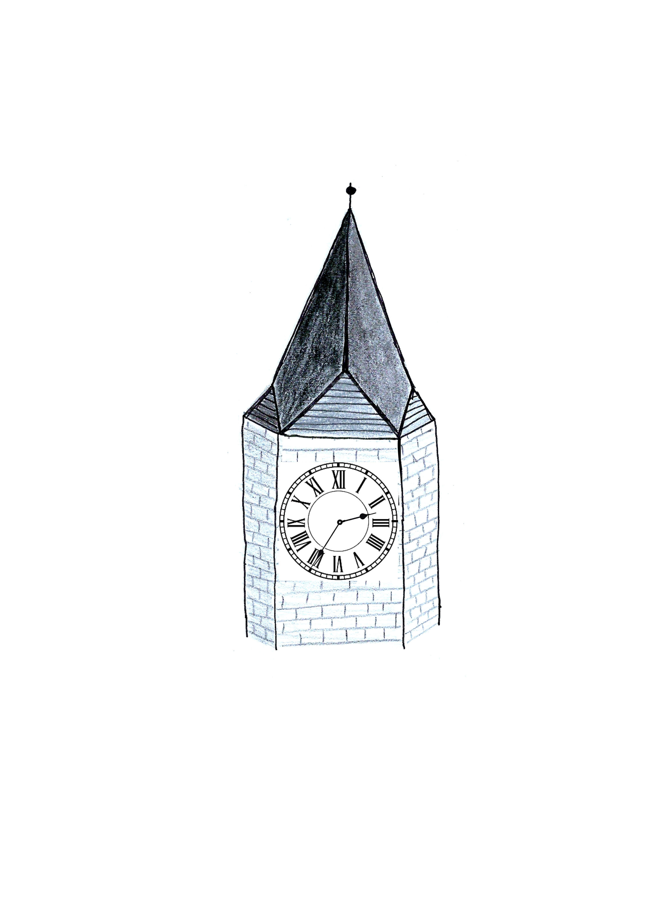

1. Als Matilda die Schule verlässt, zeigt die Turmuhr folgende Uhrzeit an.
2. Matilda will sich mit Lisa um 15.15 Uhr am Kino treffen.

In wie vielen Minuten trifft sie Lisa? _____________

1. Das Ziffernblatt der Turmuhr hat einen Durchmesser von 6,54 m.

Wie groß ist der Radius des Ziffernblattes?

|  |  |  |  |  |  |  |  |  |  |  |  |  |  |  |  |  |  |  |  |  |  |  |  |  |  |  |
| --- | --- | --- | --- | --- | --- | --- | --- | --- | --- | --- | --- | --- | --- | --- | --- | --- | --- | --- | --- | --- | --- | --- | --- | --- | --- | --- |
|  |  |  |  |  |  |  |  |  |  |  |  |  |  |  |  |  |  |  |  |  |  |  |  |  |  |  |
|  |  |  |  |  |  |  |  |  |  |  |  |  |  |  |  |  |  |  |  |  |  |  |  |  |  |  |
|  |  |  |  |  |  |  |  |  |  |  |  |  |  |  |  |  |  |  |  |  |  |  |  |  |  |  |
|  |  |  |  |  |  |  |  |  |  |  |  |  |  |  |  |  |  |  |  |  |  |  |  |  |  |  |

Antwort: __________________________________________________

1. Der Minutenzeiger der Turmuhr ist 2 m und 68 cm lang.

Der Stundenzeiger der Uhr ist 104 cm kürzer als der Minutenzeiger.

Wie lang ist der Stundenzeiger?

|  |  |  |  |  |  |  |  |  |  |  |  |  |  |  |  |  |  |  |  |  |  |  |  |  |  |  |
| --- | --- | --- | --- | --- | --- | --- | --- | --- | --- | --- | --- | --- | --- | --- | --- | --- | --- | --- | --- | --- | --- | --- | --- | --- | --- | --- |
|  |  |  |  |  |  |  |  |  |  |  |  |  |  |  |  |  |  |  |  |  |  |  |  |  |  |  |
|  |  |  |  |  |  |  |  |  |  |  |  |  |  |  |  |  |  |  |  |  |  |  |  |  |  |  |
|  |  |  |  |  |  |  |  |  |  |  |  |  |  |  |  |  |  |  |  |  |  |  |  |  |  |  |
|  |  |  |  |  |  |  |  |  |  |  |  |  |  |  |  |  |  |  |  |  |  |  |  |  |  |  |
|  |  |  |  |  |  |  |  |  |  |  |  |  |  |  |  |  |  |  |  |  |  |  |  |  |  |  |
|  |  |  |  |  |  |  |  |  |  |  |  |  |  |  |  |  |  |  |  |  |  |  |  |  |  |  |

Antwort: __________________________________________________