

Zentrale Klassenarbeit 2021

GYMNASIUM

Englisch

Schuljahrgang 6

Teile A und B

Arbeitszeit: Teil A: 10 Minuten
Teil B: 35 Minuten

Thema: Family

Name, Vorname: ________________________________________

Klasse: ____________

Teil A: Listening Comprehension
I The Royal Family
Listen to some surprising facts about Britain’s Royal family. While listening, match the statements (1 – 3 ) with the headings (A – D). There is one more heading than you need.
You will hear the recording once only.
You now have 10 seconds to look at the task.

Headings
A | Flying alone
B | Royal dinner
C | The Queen chooses
D | No need for documents

Statement | 1 | 2 | 3
Heading

3 BE

II A Big Family
Listen to the following interview. While listening, complete the information in the following table.
You will hear the recording twice.
You now have 20 seconds to look at the task.

1 | How many children are there in the girl’s family?
2 | What is special about the girl’s brothers?
3 | What does the girl hate about living in a big family?
4 | What is the number of rooms in the house?
5 | How many other girls share a room with her?
6 | When does the family have meals together?
7 | What does the girl like best about her family?

7 BE

III An Expert for Pets
Listen to the following radio show. While listening, tick the correct statements. There is only one correct answer.
You will hear the recording once only.
You now have 30 seconds to look at the task.

- If you want to keep a pet, you must …
a) | always buy a pair. | k,,
b) | invest a lot of money. | k,,
c) | spend a lot of time with it. | k,,
d) | buy it when it is very young. | k,,

- Pets can be a great help because they are …
a) | very strong. | k,,
b) | warm and soft. | k,,
c) | excellent listeners. | k,,
d) | extremely clever animals. | k,,

- If a pet does not get enough love, it will …
a) | be sad. | k,,
b) | get crazy. | k,,
c) | run away. | k,,
d) | become aggressive. | k,,

3 BE
Teil B Language in Use, Reading Comprehension, Mediation and Writing

I Language in Use
Complete the following sentences. Tick the correct box (a, b, c or d).
- My brother is …
a) | tall as my father. | k,,
b) | taller than my father. | k,,
c) | as taller as my father. | k,,
d) | more taller than my father. | k,,

- We visited …
a) | the old castle near Dover yesterday. | k,,
b) | the old castle yesterday near Dover. | k,,
c) | yesterday near Dover the old castle. | k,,
d) | yesterday the old castle near Dover. | k,,

- My mother …
a) | bring some flowers. | k,,
b) | brang some flowers. | k,,
c) | brewed some flowers. | k,,
d) | brought some flowers. | k,,

- How …
a) | much money need we? | k,,
b) | much do we need money? | k,,
c) | many money do we need? | k,,
d) | much money do we need? | k,,

4 BE

In the following words you do not hear each letter. Which one is it? You may use your dictionary.
s
example: island l

- sword b) comb c) knit

3

II Reading Comprehension
Read the following email.
From: Sophia<sophiathebeautiful@coldmail.de>
To: Olivia
Subject: Breaking News
Dear Olivia
Time flies, the weekend is over.I was surprised when you called me yesterday afternoon. I’m sorry, I didn’t have much time to talk to you on the phone. Let me tell you why. Imagine, my aunt and uncle stayed with us for the weekend. Nothing special, you’ll say, but this visit was different.
Uncle Tobias and Aunt Yasmin live abroad. They left Germany because they found good jobs in Stockholm and moved to Sweden before Christmas. My uncle is a doctor and my aunt is a nurse. They work at a hospital and are very good at English. Almost everyone understands it there. In the evenings they study Swedish and now they can speak the language quite well.
Living in Sweden is really exciting, they say. The climate is a bit different from ours. They like the winter although it’s often cold and cloudy. Now, in June, the weather is pleasant, the sun is shining and the temperatures are about 20 degrees Celsius. But, they added, the city is really crowded, because it’s the high season: temperatures are the warmest and daylight lasts the longest, so all the public places are full of tourists. Guess what! I’ll be one of them soon because Uncle Tobias and Aunt Yasmin invited us to their house. We’re going to fly to Stockholm in my summer holidays. Wonderful!
My mother wants to see “ABBA – The Museum”. She is mad about ABBA and went to the musical MAMMA MIA twice. Have you been to this show in London? You live near the theatre, don’t you? What are your plans for the summer? Have you ever visited Scandinavia?
Hope to hear from you soon.
Sophia

Answer the following questions. You need not write complete sentences.
- Why did Sophia’s aunt and uncle move to Sweden?
__________________________________________________________________________
- Why is it important for Sophia’s aunt and uncle to speak English well?
__________________________________________________________________________
- What do Sophia’s aunt and uncle do in the evenings?
__________________________________________________________________________
- What is the summer like in the city of Stockholm? (2 facts)
__________________________________________________________________________
__________________________________________________________________________
- Why is Sophia looking forward to the summer holidays?
__________________________________________________________________________
- Where is Olivia from?
__________________________________________________________________________

7 BE

III Mediation – Smugglers’ Adventure
The Smugglers’ Caves
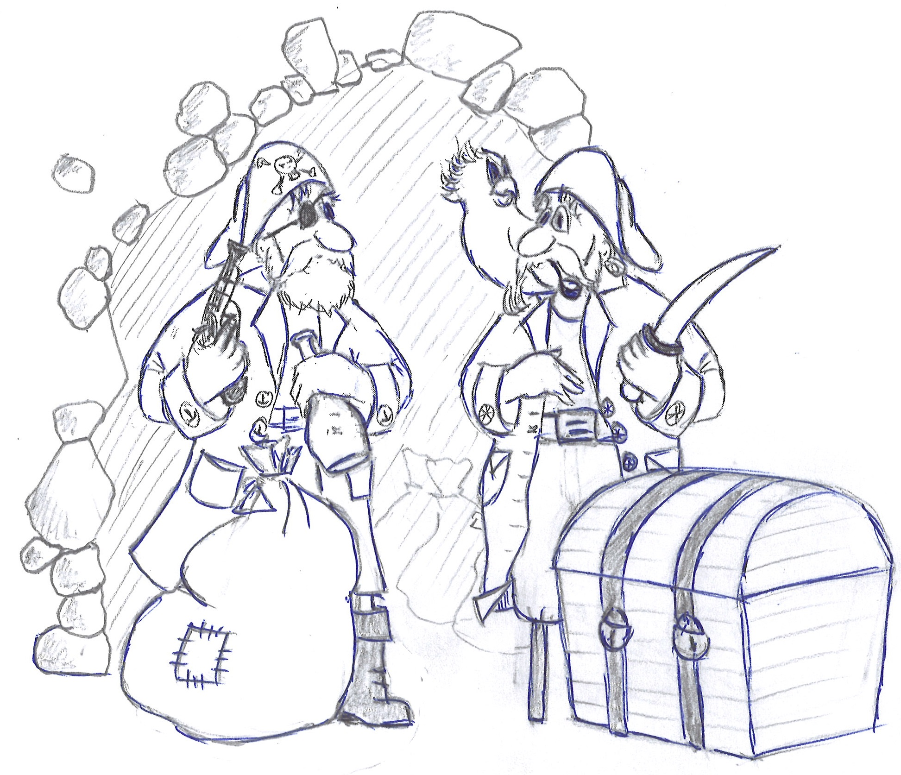

The Smugglers’ Caves are on the West Hill in Hastings, East Sussex.
A tour is about one hour.
- Walk through 44 metres of mysterious tunnels. HAIRY JACK guides you.
- Learn something about the dark secrets of the smugglers.
- Enjoy dramatic sound effects and lighting.
- Meet more than 50 life-size wax figures.
- Press buttons and you will find out where the pirates hid their treasures 200 years ago.
- Look at swords, uniforms, guns and many other things.
- Imagine, there’s also a real smuggler’s journal. You can read about how they spent their money.

OPENING TIMES
FEBRUARY TO NOVEMBER10am – 6pm(last admission 5pm)
HOW TO GET THERE
Park your car in the seafront car park. Take the West Hill Cliff Railway, which is on George Street.

ADMISSION
Standard£ 8.75Senior (aged 65+)£ 8.25
Junior (aged 3-12)£ 6.75Family of four£ 30

Du bist mit deiner Familie in Hastings, an der Südküste Großbritanniens. Dein Bruder sieht ein Poster mit gruseligen Schmugglern, die vor einer Höhle stehen und stellt dir nun folgende Fragen. Beantworte diese in deutscher Sprache!

1. Dein Bruder: Sag mal, wo genau sind denn diese Höhlen?

Du:

2. Dein Bruder: Wozu haben die Piraten die Höhlen benutzt?

Du:

3. Dein Bruder: Was kann man noch anschauen? (2 Fakten)

Du:

4. Dein Bruder: Was kostet der Eintritt für unsere Familie?

Du:

5. Dein Bruder: Können wir die Höhlen auch nachts besuchen?

Du:

6 BE

IV Writing
Write about a perfect weekend you spent with your family. (Think about the following: Who? When? What? Where? What did you like best? …)
Write ca. 70 words.

Count your words: _______________
10 BE

