Be creative!

As a Green Champion you want to inform people about the environmental impact the production of a T-shirt has and what we can do to stop the pollution of our environment.
- Create a poster or a video that shows the facts.
or
Write and act out a scene in which you interview a T-Shirt about its life or the manager of a firm which produces and sells T-shirts.

This is not the way a T-shirt should end!
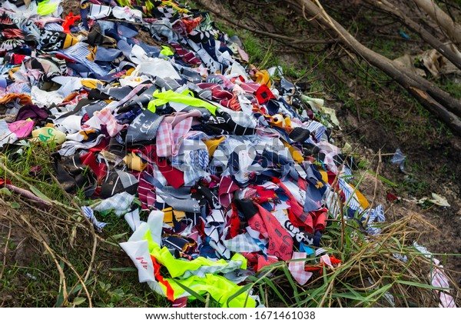
(Bild Shutterstock: https://www.shutterstock.com/de/image-photo/trash-that-piece-cloth-old-thrown-1671461038, Zugriff am 03.06.2022)

So, what can we do?
YES! Let’s have a clothes swap party.

A Clothes Swap Party
- As a class-project plan a clothes swap party. You need to consider the following aspects:
2.1 Put together information for parents and teachers:
- As you need the help of your parents and your teachers, inform them in German about important advice and instructions to follow based on the English text.
- Decide which of the statements and facts are really useful for the instruction.
- Inform them about the reasons and the aim of your clothes swap party.
- Tell them what you need and how the party goes. Some of you can create a poster, showing everybody when and where the party is, and the clothes you want to swap.
2.2 Party organization:
- It's fun, doesn't cost anything and helps to protect our environment. Now, start to organize a clothes swap party with your friends.
- Consider the following information:
Welcome to a Clothes Swap Party
Are you in the mood for new clothes?
By choosing what to wear, we try to show what we find cool. And we need clothing because it keeps us warm, dry, protects us and is part of our culture.
The only question is whether we have to keep shopping for new clothes. The production of clothes consumes vast amounts of resources such as water and oil and is very energy-intensive. In addition, poisonous chemicals are used in many of the mostly poor manufacturing countries. They often get unfiltered from the factories into the water and contaminate the drinking water of millions of people.
Fortunately, there are ways to live out your joy in fashion and clothes without polluting the environment so much. The magic word is second hand. Organize your own clothes swap party now - you can invite your friends to it, but you can also turn it into a class party. You can, for example, deal with the topic of "fast fashion" in a project week and organize a clothes swap party at the end.

2.3 Your checklist for your own clothes swap party:
- Inform your teachers and your parents about your plan and ask for help.
- Organize a room where the party should take place.
- Decide how many items of clothing everyone can offer and how many items of clothing everyone can choose.
- The clothes should be clean and in good condition.
- Set up the tables in a U-shape in the classroom and present the clothes on them.
- Sort the clothes according to size and type.
- Think of mirrors and changing rooms, maybe you can use the neighbouring classrooms for this.
- A clothes swap party is even more fun when there is some music playing in the background. Maybe after swapping clothes it will turn into a dance party. There are institutions (e.g. the Diakonie) that accept clothing donations. Talk with your teacher and parents who will help you with it.
- If you want, you can spice up your party with drinks and snacks.
Have fun!

(adapted from: https://kids.greenpeace.de/tipp/kleidertauschparty (Zugriff: 07.11.2022))
Icons used: <a href="https://www.flaticon.com/free-icons/lightbulb" title="lightbulb icons">Lightbulb icons created by Freepik - Flaticon</a>; <a href="https://www.flaticon.com/free-icons/stop" title="stop icons">Stop icons created by Freepik - Flaticon</a> (Zugriff: 07.11.2022);
Bilder in Moodle Aufgabe unter Standartlizenz adobe stock, Klavidyav: 497319471, Fotoksa: 495534755, HollyHarry: 336260206 (Zugriff: 19.12.2022)

