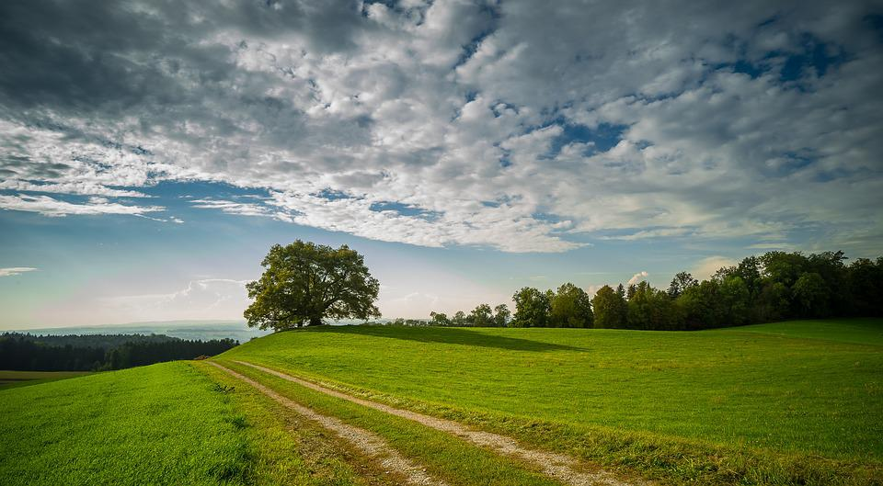
Become a Green Champion
(Bild Pixabay: https://pixabay.com/de/photos/landschaft-natur-baum-wolken-3688043/, Zugriff am 02.06.2022)
Quiz: Are you a green champion?
Everyone knows that we need to live a greener lifestyle. Using a re-useable bag when you and your family go shopping is certainly a small step. Are you and your family already living an eco-friendly lifestyle?
Take this quiz to find out how green you and your family are.

- Do you talk to your friends and family about environmental problems?
a) always/often/regularly | b) sometimes | c) never
- Are you part of a climate conscious or green organization and support their work?
a) yes |  | c) no
- Do you use renewable energy in your home?
a) always/often/regularly | b) sometimes | c) never
- Do you close the door to keep the heat in?
a) always/often/regularly | b) sometimes | c) never
- Do you recycle bottles, cans and paper?
a) always/often/regularly | b) sometimes | c) never
- Do you use the washing machine only when you have a full load?
a) always/often/regularly | b) sometimes | c) never
- Do you dry your washing outside when the weather in fine?
a) always/often/regularly | b) sometimes | c) never
- Do you give old clothes to charity?
a) always/often/regularly | b) sometimes | c) never
- Do you check the energy efficiency rating when you buy technical or electronic devices?
a) always/often/regularly | b) sometimes | c) never
- Do you buy local food to save on food miles?
a) always/often/regularly | b) sometimes | c) never
- Do you eat vegetarian or vegan meals?
a) always/often/regularly | b) sometimes | c) never
- Do you use re-useable bags?
a) always/often/regularly | b) sometimes | c) never

Add up your score: 2 points for each a) answer, 1 point for each b) answer, 0 point for each c) answer.

Your Green Score
- Less than 7 points: Have you even heard about climate change? You should know better.
- Between 8 and 13 points: You already do a few basic things – but you can do more to protect the environment. Some tips in the quiz can help you to become more eco-friendly.
- Between 14 and 19 points: You already do many things to protect the environment. Look at the questions you answered with sometimes and never and make some changes.
- Between 20 and 24 points: You know what to do to protect the environment. You can call yourself a Green Champion. Well done and carry on.

